6(A)

= RESTART: C:\Users\pothu\Downloads\6(A)_D2.py

[[10 0 0]

[ 0 9 0]

[ 0 0 11]]

6(B)

**= RESTART: C:\Users\pothu\Downloads\6(B).dl.py**

**[[13 0 0]**

**[ 0 16 0]**

**[ 0 0 9]]**

**6(C)**

**[[17 0 0]**

**[ 0 14 1]**

**[ 0 0 13]]**

**6(D)** 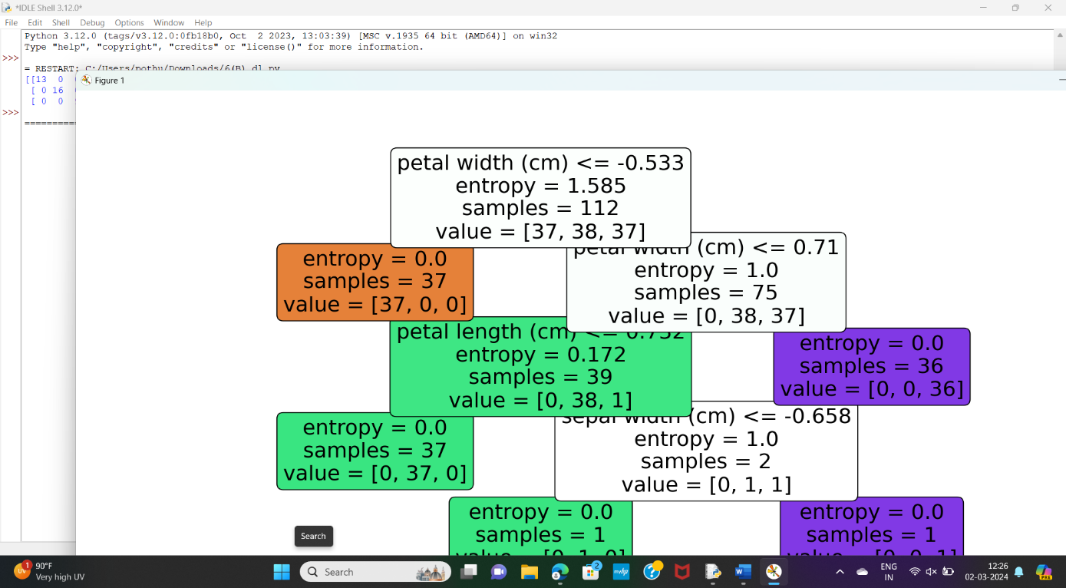

[[13 0 0]

[ 0 11 1]

[ 0 3 10]]

6(E)

[[16 0 0]

[ 0 11 0]

[ 0 0 11]]

Accuracy: 100.00%

6(F)

[[12 0 0]

[ 0 13 0]

[ 0 1 12]]

Accuracy: 0.9736842105263158

7(A)

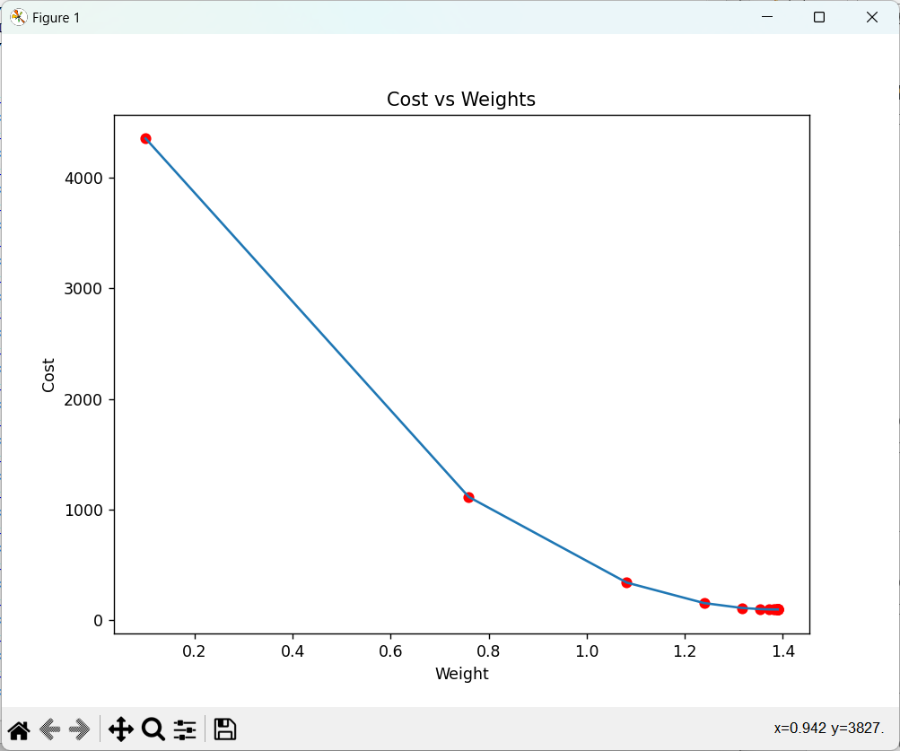

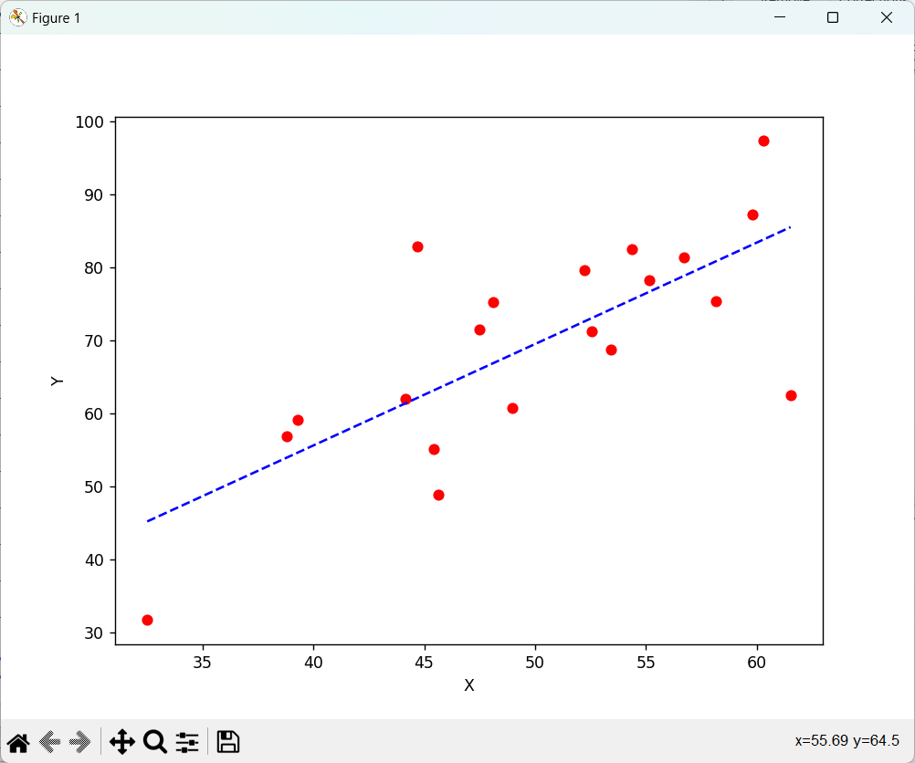

Iteration {i+1}: Cost {current_cost}, Weight /{current_weight}, Bias {current_bias}

Iteration {i+1}: Cost {current_cost}, Weight /{current_weight}, Bias {current_bias}

Iteration {i+1}: Cost {current_cost}, Weight /{current_weight}, Bias {current_bias}

Iteration {i+1}: Cost {current_cost}, Weight /{current_weight}, Bias {current_bias}

Iteration {i+1}: Cost {current_cost}, Weight /{current_weight}, Bias {current_bias}

Iteration {i+1}: Cost {current_cost}, Weight /{current_weight}, Bias {current_bias}

Iteration {i+1}: Cost {current_cost}, Weight /{current_weight}, Bias {current_bias}

Iteration {i+1}: Cost {current_cost}, Weight /{current_weight}, Bias {current_bias}

Iteration {i+1}: Cost {current_cost}, Weight /{current_weight}, Bias {current_bias}

Iteration {i+1}: Cost {current_cost}, Weight /{current_weight}, Bias {current_bias}

Iteration {i+1}: Cost {current_cost}, Weight /{current_weight}, Bias {current_bias}

Iteration {i+1}: Cost {current_cost}, Weight /{current_weight}, Bias {current_bias}

Iteration {i+1}: Cost {current_cost}, Weight /{current_weight}, Bias {current_bias}

Iteration {i+1}: Cost {current_cost}, Weight /{current_weight}, Bias {current_bias}

Iteration {i+1}: Cost {current_cost}, Weight /{current_weight}, Bias {current_bias}

Iteration {i+1}: Cost {current_cost}, Weight /{current_weight}, Bias {current_bias}

Iteration {i+1}: Cost {current_cost}, Weight /{current_weight}, Bias {current_bias}

Estimated Weight: 1.389738813163012

Estimated Bias: 0.03509461674147458

7(B)

